***I have what???***

A patient’s guide through the maze of

Hereditary Spastic Paraplegia

***What are the symptoms of HSP?*** The hallmark of HSP is progressive difficulty walking due to increasingly weak and stiff (spastic) muscles. Symptoms appear in most people between the second and fourth decade of life, but they can start at any age.

Researchers estimate that over 70 different types of HSP exist; the genetic causes are known for 59! The HSP incidence rate in the United States is 10,000 – 30,000 people.

***What is HSP?***

HEREDITARY SPASTIC PARAPLEGIA (HSP) IS A GROUP OF RARE, INHERITED, NEUROLOGICAL DISORDERS. THEIR PRIMARY SYMPTOMS ARE PROGRESSIVE SPASTICITY AND WEAKNESS OF THE LEG AND HIP MUSCLES.



Initial symptoms are typically difficulty with balance, stubbing the toe or stumbling. Changes begin so gradually that other people often notice the change first. As the disease progresses, canes, walkers and eventually wheelchairs may become needed, although some people never require assistive devices.

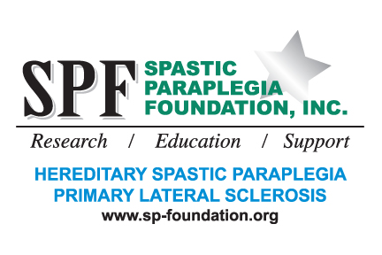

***What should I expect?***

Everyone is different!

Just like a snowflake,

we are all individuals,

but together we are snow.

**These seem to be the most common symptoms.**

**You might experience some or all of these:**

* Muscle tightness in legs/feet
* Imbalance: Frequent Falls
* Muscle spasms
* Sensitivity to cold
* Excessive muscle tone
* High arched feet
* Fatigue
* Frequency/urgency of urination



***Does stress affect my symptoms?***

Many people find the tightness in their muscles worsens when they are angry, stressed, or upset. This may make it more difficult to walk and speak. It is unknown exactly how emotions affect muscle tone, but it may involve adrenalin levels. Most people also report increased stiffness in cold weather.

The cell bodies of these neurons are located in the motor cortex area of the brain. They have long, hair-like processes called axons that travel to the brainstem and down the spinal cord.

HSP is caused by degeneration of the upper motor neurons in the brain and spinal cord. Even though the trouble may be with your legs, upper motor neurons control voluntary movement.

BASIC CELL BIOLOGY EXPLAINED

I’m sure you’ve gone to the doctor’s office and left there just as confused as you went in—maybe more!



Axons relay the messages to move to lower motor neurons that are located all along the brainstem and spinal cord. Lower motor neurons then carry the messages out to the muscles.

When upper motor neurons degenerate, the correct messages cannot reach the lower motor neurons, and the lower motor neurons cannot transmit the correct messages to the muscles. As the degeneration continues, spasticity and weakness increase. The legs are affected because degeneration occurs primarily at the ends of the longest nerves in the spinal cord, which control the legs. In some cases, the upper body can be minimally affected as well, leading to problems with the arms or speech and swallowing muscles.

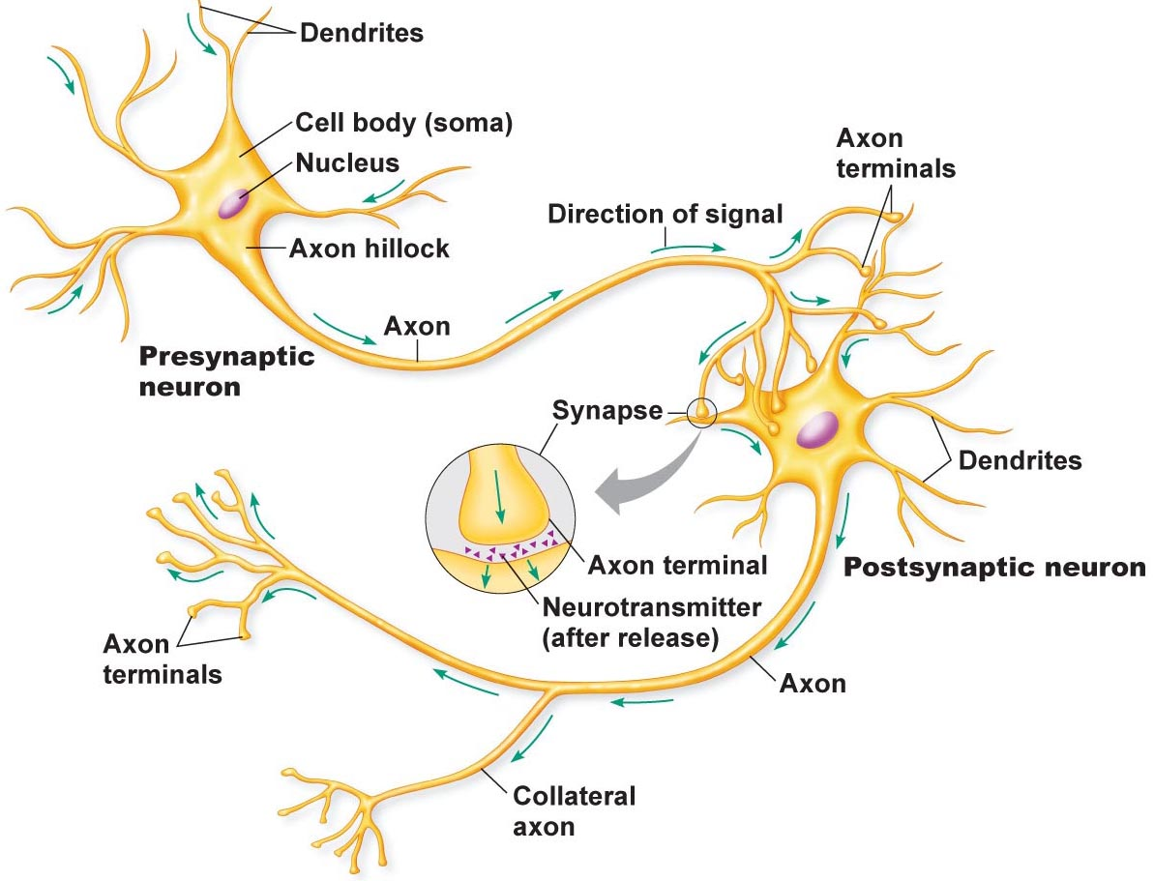

Treatment is focused on symptom relief, such as medication to reduce spasticity; physical therapy and exercise to help maintain flexibility, strength, and range of motion; assistive devices and communications aids; supportive therapy and other modalities.

This material has been reviewed by Dr. John Fink, M.D., SPF Medical Advisor. Please see Glossary to help with medical terms.

**Please note:** The information in this section is not intended to be taken as replacement for medical advice. Individuals should consult with a qualified health-care practitioner. HSP affects individual people in different ways, and as a result, treatment programs will vary. Although there is no way to stop, slow or reverse the progressive disability of these disorders, there are therapies that can help enhance function and comfort and promote general physical and emotional well-being. You are an important member of the team, too.

***WHAT CAN I DO NOW?***

***“There’s no cure or magic pill, there are only treatments***.”

--Dr. John K. Fink

The legs are affected because degeneration occurs primarily at the ends of the longest nerves in the spinal cord, which control the legs.



**STRETCHING**

There are several benefits to stretching as soon as you have been diagnosed. “I stretch several times each day!” says Jackie Wellman, SPF Board Member and Iowa State Ambassador. The overall benefit you’ll find is the alleviating of the leg cramps or spasms that become more intense with stress and exertion.

If you want to find a good stretch for you, ask your physician or therapist. Basically, you want to especially stretch your hamstrings, calves and Achilles tendons (ankle).

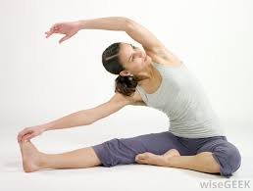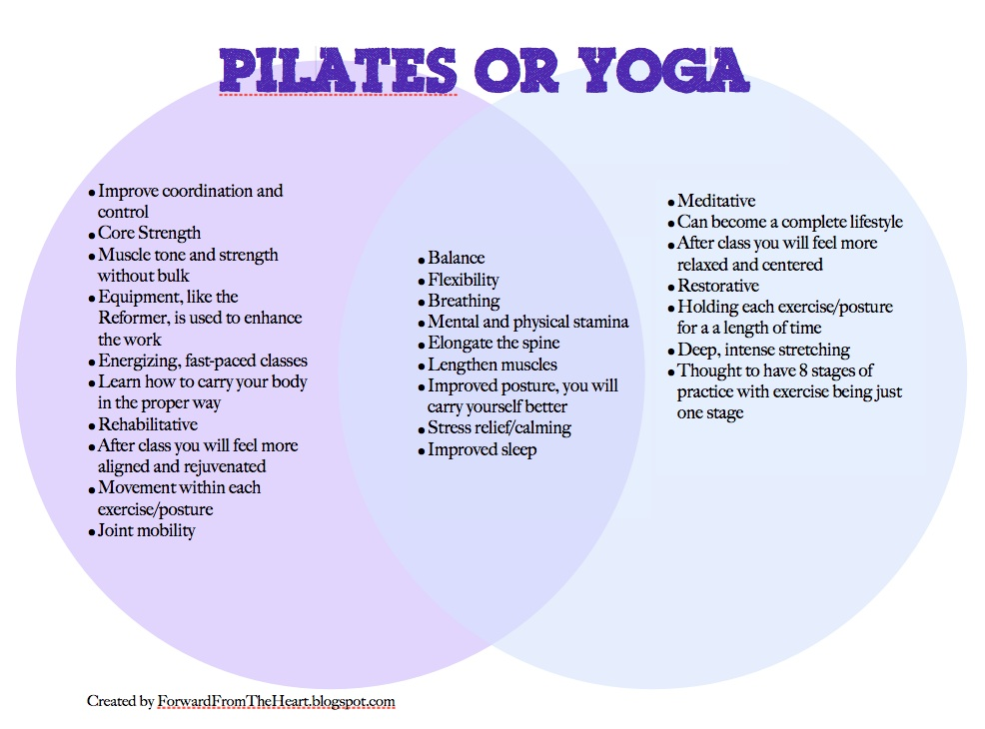

**EXERCISE!**

**“Use it or Lose it!”**

**--Harvey Mover**

Physical Therapists will assess joint motion, muscle strength and endurance, posture, pain, heart and lung function and performance of daily living activities to develop an individualized program.

Physical Therapy seeks

to restore or maintain the

ability to move. Therapies

generally focus on reducing

muscle tone, maintaining or

improving range of motion

and mobility, increasing strength

and coordination, and improving

comfort.

* Baclofen The most commonly used medication to help

relax muscles or reduce tone. Brand name: Lioresal. Outside the United States: Alpha-Baclofen, Baclon, Baclosal, Baclospas, Baklofen, Clofen, Lebic, Mulax, Pacifen, Spinax To be effective, the dose must be large enough to cross the blood/brain barrier and reach the spinal cord (The blood/brain barrier is the body’s way of keeping chemicals from getting to the brain and spinal cord).

**Physical Therapy**

**Drug Therapy**

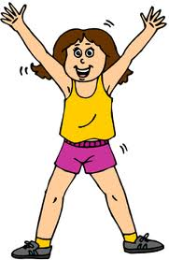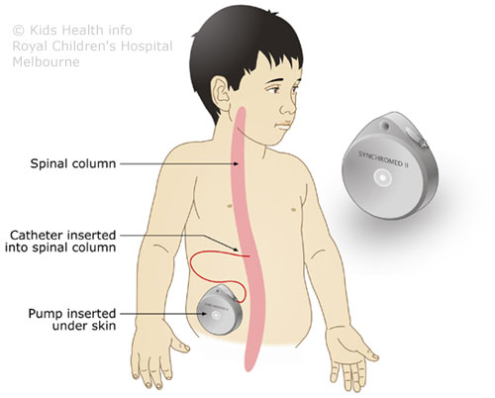

If the high dosage results in too much sedation, the **intrathecal Baclofen pump** can be considered. The Baclofen pump is surgically implanted in the abdomen and delivers small, continuous doses of medication directly to the spinal canal. This can result in better performance with minimal side effects. Surgery is required to implant the pump under the skin of the abdomen and a catheter connects it to the spine. The pump can be programmed to release a specific amount of medicine at select times, which can be adjusted without surgery. The pump needs to be refilled every one to three months. See Medtronic.

**Co-Enzyme Q10**

…is a non-prescription dietary supplement that is involved in a variety of cellular processes. It has been noted to have antioxidant properties, such as free-radical scavenging. CoQ10 is indicated for heart failure and mitochondrial cytopathies.

Researchers in a Massachusetts General Hospital study found that CoQ10 extended the survival in a mouse model of ALS. They also demonstrated positive findings in Parkinson’s and Huntington’s Disease. It is thought that CoQ10 may be useful for the treatment of neurodegenerative diseases.

**SUPPLEMENTS**

***A list of popular supplements often used by individuals with HSP are below. Their inclusion is for informational purposes only and not a recommendation or endorsement.***

* Tizanidine A short acting drug useful for treating nocturnal spasms and for intermittent management of spasticity. Brand name: Zanaflex. Outside the United States: Sirdalud, Sirdalud MR, Sirdalud Retard, Ternelax, Ternelin
* Diazepam and Clonazepam Sedatives that slow the central nervous system, side effects are common. Klonopin
* Dantrolene Sodium Works to reduce muscle contraction, may cause liver damage. Brand names: Dantrium, Dantrium IV Other treatments used for spasticity
* Botulinum Toxin Chemodenervation by injections of botulinum toxin type A (BTX-A) directly into the muscle, lasts about six months. Brand name: Botox (chemodenervation) Product site
* Gabapentin Widely used to treat seizures and neuropathic pain, may be useful in reducing spasticity. Brand name: Neurontin

**Green Tea**

An antioxidant, helps blood flow to the brain, lower cholesterol prevent a range of heart-related issues and help block the formation of plaques that are linked to Alzheimer’s disease

**Magnesium**

Good for powering the heart and aiding in constipation, but also great for alleviating muscle cramps.

**Fish oil and quinine**

Individuals have reported benefit from fish oil, which blocks activity of the sodium channels used to contract muscles and quinine. Quinine is found in tonic water.

**Melatonin**

A supplement which promotes relaxation. Some people find it helpful in promoting restful sleep.

**Alpha-Lipoic Acid**

Alpha-lipoic acid (ALA) is a non-prescriptive dietary supplement. It is a powerful antioxidant and is used to treat individuals with liver disease and Amanita mushroom poisoning.

**Vitamin E**

Vitamin E is a fat-soluble vitamin found in many foods. It is a powerful vitamin and antioxidant that detoxifies free radicals. It helps protect the cells of the body from damaging chemical reactions and it is important for the proper functioning of nerves and muscles.

There have not been studies to suggest a recommended dosage for people with neurodegenerative diseases. Patients, while under the care of their physician, appear to be taking 100mg three times per day. CoQ10 is fat-soluble and should be taken with a fatty meal. It is available over the counter at any store selling dietary supplements functioning of nerves and muscles.

Improves physical energy and athletic ability, increases immunity to colds and infections and increase sexual capacity and fertility.

**Oregano Oil**

Has been shown to function as potent antioxidants that can prevent oxygen- based damage to cell structures throughout the body.

*The list above is provided as an informational source and is not intended to be a recommendation. For detailed information, contraindications and side effects, please visit Medline Plus Health Information. For information on vitamins and food supplements, visit the USDA Food and Nutrition Information Center. And of course, consult your doctor or pharmacist*

**Orthotics (AFOs=ankle-foot-orthotics)**

Orthotics are special shoe inserts, splints or braces used to help relieve gait problems and foot problems. They can also help increase balance or remove pressure from sore spots.

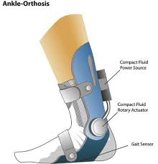

**Bacopa**

Supports healthy cognitive function

Supports attention, learning, focus, and memory

Promotes calmness, relaxation, and focus

Supports positive mood and emotional well-being

Protects the brain from oxidative damage

**Ashwagandha**

**Nutrition**

There are no known studies indicating that vitamins or food supplements are an effective treatment for PLS or HSP. However, there are studies indicating particular antioxidants may be of benefit in related neurologic conditions, such as ALS. It is generally recognized that eating a healthy, well-balanced diet is important to overall health. Individuals should always get recommendations from their physicians before taking any vitamins or food supplements. A great additional source of information is the USDA Food and Nutrition Information Center.

See also: Gluten Free, Vegetarian, Vegan, Paleo, etal

… is usually described as practices not generally accepted as part of the standard approaches used by licensed physicians or other licensed health care providers. Practitioners using these methods are generally not licensed as health care clinicians, but may be licensed for a specific method, such as acupuncture or massage, or licensed in another health field, such as nursing.

Some licensed physicians and other health care providers may use an alternative medicine method or refer patients to practitioners of an alternative medicine method. Many individuals pursue treatments on their own.

**Massage therapy:**The use of touch and various manipulation techniques

To move muscles and soft body tissues to relieve stress, tension, and

pain. For more information, see the National Certification Board for

Therapeutic Massage and Bodywork. TES is a technique used by some clinicians to improve muscle strength and muscle coordination in persons with muscle spasticity.

***A list of popular alternative medicine modalities often used by individuals with HSP are below. Their inclusion is for informational purposes only and not a recommendation or endorsement.***

**Alternative medicine**

**Magnet therapy:**Magnet therapy claims that magnet fields have healing

powers. Most of the support is anecdotal and testimonial and is generally attributed to the placebo affect. There is almost no scientific evidence supporting this theory, however, there was a large study done indicating benefit at Bayer College of Medicine. That has not been replicated. Nonetheless, there a growing industry is producing all types of products with magnets. Some individuals in our community have reported benefit. If interested in more information, see Synergy Wellness System with Magnetic Therapy.

**Meditation**: Meditation can wipe away the day’s stress, bringing with it

inner peace. If stress has you anxious, tense and worried, consider

meditation. Spending even a few minutes in meditation can restore

your calm and inner peace. Meditation isn’t a replacement for

traditional medical treatment. But it may be a useful addition to your

other treatments. Some research suggests that meditation may help

people manage symptoms of conditions such as:

*Anxiety disorders*

*Asthma*

*Cancer*

*Depression*

*Heart disease*

*High blood pressure*

*Pain*

*Sleep problems*

**Acupuncture:**An ancient system of Chinese medicine where thin needles

are inserted into specific points on the body. Chinese medicine identifies

these points as conducive to energy and connected to specific organ

systems in the body. The purpose is to alleviate various health conditions. Some individuals have indicated an improvement with spasticity after treatment.

**Chiropractic treatment:**A treatment method that depends primarily on

manipulating or adjusting the spine to prevent disease and treat pain and

other ailments. Some people have found that chiropractic spinal

manipulation can help reduce their back pain, and some claim a

temporary improvement in their gait.

**Upper Cervical Care:** is a natural form of health care that focuses on

locating and removing misalignments from one of the top two bones in your neck.

***Where do I go for help?***

SPF (Spastic Paraplegia Foundation) www.sp-foundation.org

NORD (National Organization for Rare Disorders) www.rarediseases.org

NEALS (Northeast Amyotrophic Lateral Sclerosis) www.alsconsortium.org

NIH (National Institute of Health) www.nih.gov

Social Media – SPF Face Book page

Etc.

***Where can I go for research?***

Individuals are encouraged to participate in clinical trials that will further the understanding of our conditions and their diagnosis, treatment, and cures. Please go to [clinical trials](http://clinicaltrials.gov/) and search on key words “primary lateral sclerosis” or “hereditary spastic paraplegia” to find out about relevant clinical trials.

[**www.clinicaltrial.gov**](http://www.clinicaltrial.gov)

**Alexander Technique:**The theory behind the Alexander Technique is

that by reeducating a person’s mind and body, tension can be reduced and ease of movement increased. Most information appears to be from commercial websites.

**Biofeedback:**Biofeedback treatment uses relaxation and visualization

(imagery) to lower stress levels, alleviate headaches, or reduce blood

pressure. Instruments measure information about bodily processes,

such as muscle tension, skin temperature, brain waves, and

respiration. Several studies have shown visualization to be very useful

in stress reduction. See Yahoo Guided Imagery.

***NAME***

***Address***

***Phone #***

***LIST OF RXs***

***Supplements?***

***ALLERGIES***

***Where can I find a doctor?***

Not all doctors are aware or can spot and treat HSP. Go to sp-foundation.org and click on “Find a Physician” for a list of doctors in your area.

\****A tip*** – *carry a card in your wallet with all of your drugs and supplements listed. Include any allergies. This will save you lots of time and your doctor will appreciate knowing all of them and if any possible drug interactions*.

***What about Insurance?***

Insurance companies are hard to understand normally. Add to it our complicated coverage! Basically, we’re going to say, “Try, try, try!” You are your own advocate here. Don’t let, “No” be the final word. You never know what can happen. You have nothing to lose—right? One thing that we have learned in dealing with Insurance companies, ALWAYS document WHO you talked to, WHAT TIME AND NUMBER you called, and WHAT WAS THE OUTCOME OR RESULT?

### ***Warning signs of caregiver stress***



1. **DENIAL** about the disease and its effects on the person who’s been diagnosed. I know he/she is going to get better.
2. **ANGER** at the person with the disease: that no effective treatments or cures currently exist, and that people don’t understand what’s going on. If he/she calls me one more time, I’ll scream.
3. **SOCIAL WITHDRAWAL** from friends and activities that once brought pleasure. I don’t care about getting together with the neighbors anymore.
4. **ANXIETY** about facing another day and what the future holds. What happens when he/she needs more care than I can provide?
5. **DEPRESSION** begins to break your spirit and affects your ability to cope. I don’t care anymore.
6. **EXHAUSTION** makes it nearly impossible to complete necessary daily tasks. I’m too tired for this.
7. **SLEEPLESSNESS** caused by a never-ending list of concerns. What if he/she falls and is seriously injured?
8. **IRRITABILITY** leads to moodiness and triggers negative responses and reactions. Leave me alone!
9. **LACK OF CONCENTRATION** makes it difficult to perform familiar tasks. I was so busy, I forgot we had an appointment.
10. **HEALTH PROBLEMS** begin to take their toll, both mentally and physically. I can’t remember the last time I felt good.

4 Couture Road

Southampton, MA 01073

www.sp-foundation.org

##### Spastic Paraplegia Foundation