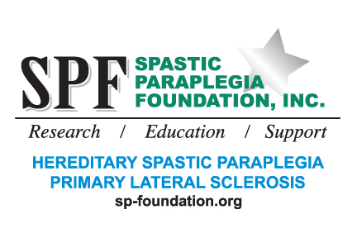

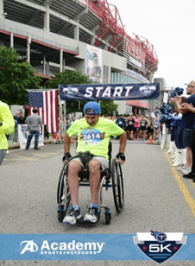

**What**: Spastic Paraplegia Foundation’s First Annual Virtual 5K (3.1 miles).

**When**: Any time during the month of Aug, in conjunction with HSP & PLS Awareness week, Aug 25-31, 2019.

**How**: If you are mobile, complete a 5K on your own. Search 5Ks in your area and participate. Many communities have greenways that you can run, walk or roll on. Check with running clubs or exercise facilities to find a route that is close by and not too hilly. If there are no greenways nearby, check with your local high school. Four times around the standard high school track and about 20 times around a basketball court equals one mile.

If you are not as mobile, complete stretching or exercises equal to a 5K. According to Google, the average person walks about 3.1 miles per hour. Choose what is safe for you and get a workout for about an hour. Do you see a physical therapist? Count that time as your 5K. Can’t do one hour straight? Then divide and conquer. Set up several times in one week to complete. Please check with your healthcare professional before doing anything new.

**Why**: To help raise money for HSP and PLS medical research. Recruit family and friends to join you. They can sponsor you by the mile, by the minute or just make a contribution to SPF. Checks should be made out to SPF and mailed to: Spastic Paraplegia Foundation, 1605 Goularte Place, Fremont, CA 94539-7241. Donations can also be made online at <https://www.sp-foundation.org>

Exercise is important for general health and especially important for wheelchair users, here are some of the benefits of exercise:

* It helps to tone your muscles and improve your overall health.
* Exercising ensures that your weight is in check.
* It helps to maintain a certain fitness level.
* It increases your flexibility, mobility, body awareness, and muscle strength.
* Exercising generate endorphins which is an anti-depressant.
* As your mental health improves, you will feel good about yourself and gain confidence.
* It reduces stress levels.
* It helps to improve blood circulation, spine stability, and posture.
* Can help with constipation.

For more information, please send email to [information@sp-foundation.org](mailto:information@sp-foundation.org)