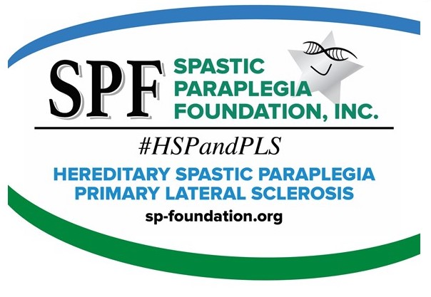
A
Acupuncture
Acupuncture is an alternative therapy treatment. It is an ancient system of Chinese medicine where thin needles are inserted into specific points on the body. These points are thought be connected to specific organ systems. The purpose is to alleviate various health conditions, including headaches, nausea and addiction.
(AFO) Ankle Foot Orthotics
See Orthotics.
Allele
Any one of a series of two or more different genes that occupy the same position (locus) on a chromosome. In the case of dominant and recessive alleles, the dominant allele will prevail over a normal allele. A recessive allele (gene) will usually show its trait only if there are two (2) copies of the allele.
Amyotrophic Lateral Sclerosis (ALS)
ALS is a rapidly progressive, fatal, neuromuscular disease. Fifty percent (50%) of ALS patients die from respiratory failure or pneumonia within three to five years of diagnosis. The condition is marked by degeneration of the upper motor and lower motor neurons. It is characterized by progressive muscle weakness, atrophy, stiffness, spasticity and fasciculations. Symptoms commonly appear in middle to late adulthood. There are some slow progressive forms of ALS. Also called Lou Gehrig’s Disease, or Motor Neuron Disease.
Amino Acid
One of the twenty building blocks of protein. They are the key components in all living things.
Anticholinergics
Anticholinergics are agents that inhibit the involuntary contractions of the bladder. They can also help increase the capacity of the bladder. Anticholinergics are often prescribed for treating urge incontinence.
Antioxidant
A chemical compound or substance that inhibits oxidation.
Antispasmodics
Antispasmodic drugs help reduce spasms, stiffness and cramps. For PLS and HSP, various types of antispasmodics may be prescribed to help reduce muscle spasticity and spasms.
(Apparently Sporadic) Spastic Paraplegia (SP)
SP is often a term used when all the signs and symptoms indicate Hereditary Spastic Paraparesis (progressive spasticity and weakness in the legs), but there is no documented family history to prove that the disorder is genetic. Clinicians may diagnose this situation as HSP, SP or Primary Lateral Sclerosis. See HSP/Heredity.
Atrophy
The progressive loss of muscle mass, or wasting, caused by reduction in the size or number of muscle cells due to lower motor neuron damage. It is generally not a symptom of PLS or HSP, except in rare cases.
Autosome/Autosomal
An autosome is a chromosome that is not the sex determining chromosome. Humans have 23 pairs of autosomes and one pair of sex chromosomes. The term autosomal means that the gene responsible for the disorder is located on one of the autosomes.
Axon
The long, hair like extension of a nerve cell that carries a message to the next nerve cell. Each nerve cell (neuron) has one axon, which can be over a foot long, and sometimes many feet long. Nerve cells communicate with each other by transmitting electrical signals from the branches at the ends of their axons. They receive signals at extensions called dendrites.
B
Babinkski’s signs
A pathological reflex where the great toe extends and flexes toward the top of the foot and the other toes fan out when the sole of the foot is firmly stroked. Babinkski’s signs are commonly seen in PLS and HSP.
Baclofen Pump
Is surgically implanted under the skin of the abdomen and delivers a small, continuous dose of medication directly to the spinal canal through a catheter. The “pump” can be programmed to release a specific amount of medicine at select times, which can be adjusted without surgery. The pump needs to be refilled every one (1) to three (3) months. See Medtronic.
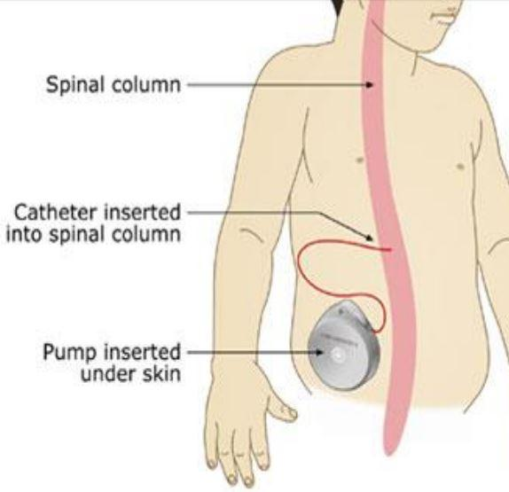
Biochemistry
The chemistry of biology; the application of the tools and concepts of chemistry to living systems. Biochemists study the structures and physical properties of biological molecules.
Biofeedback
Treatment that uses relaxation and visualization to lower stress levels, alleviate headaches, or reduce blood pressure. Instruments measure information about bodily processes, such as muscle tension, skin temperature, brain waves, and respiration.
Bulbar Muscles
The muscles that control the speech, chewing and swallowing. Bulbar muscles are affected in PLS but rarely in HSP.
C
Carrier
A person who has an affected recessive gene but usually does not show the effects of that gene because he or she also has an unaffected gene. Normally, being a carrier of a recessive disorder is not harmful to the carrier. Because carriers have one affected gene, they can pass that gene to their children – however, unless the other parent is also a carrier, it is unlikely that any children will be affected by the disorder, although they may be carriers as well.
Celebrex
Celebrex is an FDA-approved drug for the treatment of rheumatoid arthritis, osteoarthritis and pain. Johns Hopkins University has tested Celebrex in the (ALS) SOD mouse model. It was shown to extend the life of the mouse by some 25% as well as protect neurons against chronic injury by a substance called glutamate.
Central Nervous System (CNS)
The brain and spinal cord combined.
Cerebellum
The portion of the brain in the back of the head between the cerebrum and the brain stem. It is responsible for motor control.
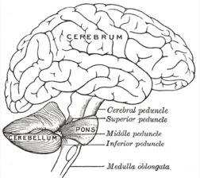
Cerebra Spinal Fluid Analysis (Spinal Tap)
A procedure used to isolate cerebrospinal fluid for evaluation or diagnosis of disease. The analysis is normal in HSP and PLS patients.
Chiropractic
A treatment method that depends primarily on manipulating or adjusting the spine to prevent disease and treat pain and other ailments, such as backaches, tension and carpal tunnel syndrome.
Chromosome
Chromosomes are self-replicating, genetic structures of cells. They are located within every cell of the human body and contain pieces of information (genes) called DNA. The DNA in each chromosome contains many genes.
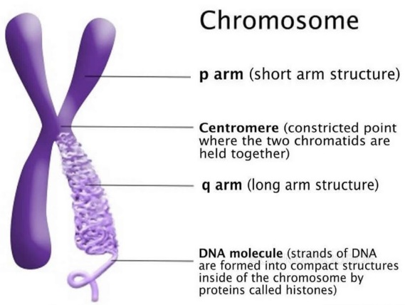
Chronic
Marked by long duration or frequent recurrence.
Clonus
Clonus is a repetitive jerking of muscles (a series of muscle contractions) that occurs when there is a disruption of the signals from the brain that normally inhibit muscle contractions. This disruption may be due to the effects of HSP or PLS on stretch reflexes.
Co-Enzyme Q10
Co-Enzyme Q10 is a non-prescription dietary supplement that is involved in a variety of cellular processes. Some studies show it may be helpful for neurodegenerative diseases.
Complicated HSP
Some forms of HSP are considered “complicated” because they involve additional neurologic symptoms in addition to progressive spasticity and weakness in the legs. These conditions include peripheral neuropathy, ichthyosis (a skin disorder) epilepsy, ataxia, optic neuropathy, retinopathy, dementia, mental retardation, deafness, or problems with speech, swallowing or breathing.
Cortico-Spinal Tracts
The cortico-spinal tracts, also called the upper motor neurons, are the long nerves that run from the brain to the spinal column. They synapse onto spinal neurons (lower motor neurons) that begin in the spinal cord and travel to the arms and legs.
Cortex
The outer layer of the cerebrum densely packed with nerve cells.
Creatine
Creatine is a dietary supplement that is promoted for its ability to enhance muscle strength and physical endurance. A study with ALS mice found that the mice had significant improvements in their survival with creatine.
D
Dementia
Not a disease itself, but group of symptoms that is characterized by a decline in intellectual functioning that is severe enough to interfere with the ability to perform routine activities.
Demyelinating
Loss of the myelin sheath that surrounds nerves. Loss of myelin is not a factor in most forms of HSP and PLS.
Dendrite
Extensions from the neuron cell body that take information to the cell body. A single nerve may possess many dendrites.
Dominant
If a dominant gene produces a particular trait or disorder, a person only needs to have one gene with that trait for it to appear, even if the other corresponding gene is normal.
Dysarthria
A speech disorder that is due to a weakness or incoordination of the speech muscles. Speech is slow, weak, imprecise or uncoordinated.

Dysphagia
The medical term for any difficulty or discomfort when swallowing. A normal swallow takes place in four stages and involves 25 different muscles and five different nerves.
E
Emotional Lability
Emotional Lability is uncontrolled laughter and crying that does not reflect how a person actually feels. This condition can affect people who have diseases or injuries of the brain and nervous system. The exact cause is unknown, but researchers believe it may result from disruptions in certain pathways in the brain that are important in expressing or controlling emotions.
F
Fasciculation
Small, involuntary, irregular, visible contractions of individual muscle fibers caused by damage to the lower motor neurons. This symptom is usually not associated with PLS or HSP since these disorders are primary upper motor neuron disorders. However, some patients have minimal lower motor neuron involvement and therefore expect this symptom.
FDA (U.S. Food and Drug Administration)
The branch of federal government responsible for protecting the public health by assuring the safety, efficacy, and security of human and veterinary drugs, biological products, medical devices, our nation's food supply, cosmetics, and products that emit radiation.
Familial
Occurring within a family. Although this term may be used when referring to hereditary disorders, the cause may not necessarily be hereditary. For example, an environmental problem such as exposure to toxic chemicals may cause a problem with several members of the same family (and thus be “familial”), but it is not hereditary.
Familial Spastic Paraplegia
See Hereditary Spastic Paraplegia
Free Radicals
Chemicals that are highly reactive and can oxidize other molecules (i.e. Superoxide).
G
GDNF (Glial Derived Neurotrophic Factor)
GDNF is a naturally occurring growth factor that proved capable of protecting and promoting the survival of motor neurons in animal studies. A growth factor is a growth inducing protein found in the human body.
Genes
Pieces of genetic information stored in codes in DNA that carry the instructions for making all of the proteins a cell needs and which determine traits such as hair and eye color. Genes contain the hereditary information that is passed on from parents to children when the sperm and egg containing the genetic information from each parent are combined during conception.
Genome
All the genetic material in a particular organism that is contained in the chromosomes. The “human genome” is the collection of genes that is necessary to make a human being.
Glutamate
Glutamate is a neurotransmitter that sends signals in the brain and throughout the nerves in the body. Glutamate plays an important role during brain development. Normal levels of glutamate also help with learning and memory. Having too much glutamate in the brain has been associated with neurological diseases such as Amyotrophic Lateral Sclerosis (ALS) and Alzheimer’s disease.

Gluteus Muscles (Glutes)
A group of muscles located in the buttock region. Helpful in normal gait.
Growth Factor
A naturally occurring protein chemical that stimulates cell division differentiation and proliferation. It is produced by normal cells during embryonic development, tissue growth and wound healing.
H
Hereditary
A trait or disorder that is inherited from the parents through genetic information.
Hyperactive Reflexes, Hyperreflexia
Under normal circumstances, the stretch receptors in muscles and tendons send reflexes to the spinal cord and brain telling them when a muscle is stretched. A signal is automatically returned to the nerves that control the muscles, telling them to contract. Under normal circumstances, the brain sends signals to control and reduce the contraction reflex. In some cases, there is a disruption of those signals, resulting in hyperactive reflexes, in which the reflex is greatly exaggerated. This is a common symptom of HSP and PLS.
Hyporeflexia
Weak or absent muscle response when a normal stimulus is applied.
Hereditary Spastic Paraplegia (HSP)
HSP is a term for a group of inherited primary upper motor neuron disorders that cause progressive spasticity (stiffness) and weakness of the leg and hip muscles. There is 90+ types of HSP. Rare forms cause additional neurological symptoms as well.
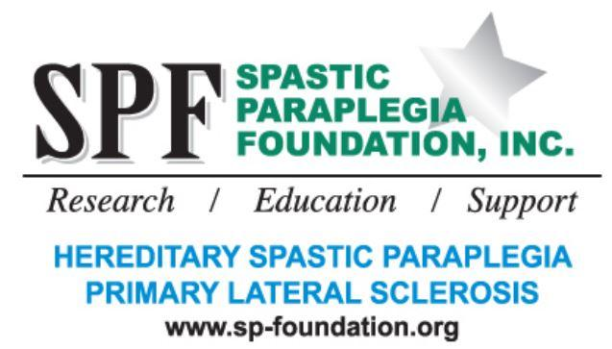
Homeopathy
One of the original alternatives to conventional medicine homeopathy uses small, diluted doses of substances that cause illnesses as a means of curing them.
Hydrotherapy
The use of water, from sources such as natural springs, seaweed baths, or mud baths, as medical treatment. Other forms of hydrotherapy include ice packs, whirlpool baths, steam baths, and saunas. Hydrotherapy can be used to treat stress, headaches, muscle aches, arthritis and bursitis.
I
Ichthyosis
A skin disorder causing dry, rough, scaly skin that may be a symptom in some forms of complicated HSP.
Incidence
Incidence is commonly measured in new cases per 1,000 (or 100,000) of population at risk, per year. Due to rarity and diagnosis inconsistencies, however, it is difficult to estimate an accurate incidence rate for HSP and PLS. The incidence of HSP is estimated at 25,000 in the United States, and 3,000 for PLS.
Immune System
A complex system that is responsible for distinguishing us from everything foreign to us and for protecting us against infections and foreign substances. The immune system works to seek and kill invaders.
Intrathecal
Injection into the innermost membrane surrounding the central nervous system. Usually done by lumbar puncture.
J
There are no entries for this letter
K
There are no entries for this letter
L
Locus
The site on a chromosome where the gene for a particular trait is found. Any one of the alleles for a gene may be found at this site.
Lower Motor Neuron
Nerve cells starting at the spinal cord or brain stem and ending at the muscle fibers. The loss of lower motor neurons leads to weakness, twitching of muscles (fasciculations), and loss of muscle bulk (atrophy).

M
Magnetic Resonance Imaging (MRI)
A non-invasive procedure that produces a two-dimensional view of an internal organ or structure, especially the brain and spinal cord.
Massage
The use of touch and various manipulation techniques to move muscles and soft body tissues to relieve stress, tension, and pain.
Minocycline
Minocycline is an antibiotic that has been shown to delay onset and slow progression of symptoms in a mouse model for ALS. Previous studies have shown the antibiotic protects neurons from dying in animal models for a variety of neurologic disorders.
Mitochondria
The mitochondria are the principal energy source of the cell. Mitochondria convert nutrients into energy as well as doing many other specialized tasks.
Molecule
The smallest unit of a substance that can exist alone and retain the character of that substance.
Motor Neuron Disease (MND)
A group of disorders in which motor nerve cells (neurons) in the spinal cord and brain stem deteriorate. ALS (Lou Gehrig’s Disease) is the most common motor neuron disease, commonly referred to as Motor Neuron Disease. PLS and HSP are atypical motor neuron disorders because they are primarly upper motor neuron disorders.
Muscle Atrophy
Loss of muscle fiber volume characterized by a visible decrease in muscle size. This occurs because muscles no longer receive impulses or signals from nerve cells. It is not a symptom in HSP and PLS, although muscles may exhibit atrophy due to misuse.
Muscle Cramp
Unexpected, involuntary, painful shortening of muscles. Usually, a knotting of the muscles is visible. Muscle cramps (spasms) are common in PLS and HSP.
Muscle Weakness
Loss of strength, increased fatigue, loss of coordination and difficulty with motor skills, and lack of ability to carry out certain skills.
Myelin Sheath
The coating on the neurons (nerve cells) that acts as an insulator to speed the conduction of nerve impulses. It is similar to the insulation coating on an electrical wire.
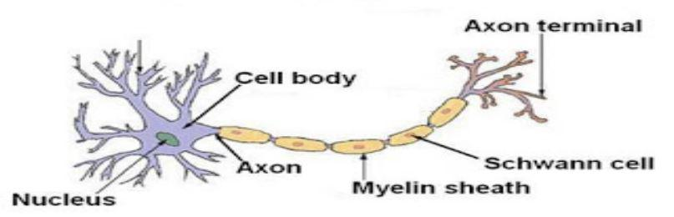

N
Nerves
A bundle of fibers that uses electrical and chemical signals to transmit sensory and motor information from one body part to another. See Neuron.
Neuron
A neuron is a special cell that transmits electrical signals. It consists of a nucleus, a single axon which conveys electrical signals to other neurons and several dendrites which deliver incoming signals. A single neuron can be several feet in length. Neurons receive input from sensory cells or other neurons and send a signal to muscles or other neurons. Neurons that have sensory input are called “sensory neurons”. Neurons with muscle outputs are called “motor-neurons”, and those that only connect to other neurons are called interneurons.
Nervous System
The system of cells, tissues and organs that regulates the body’s responses to internal and external stimuli. In vertebrae it consists of the brain, spinal cord, nerves, ganglia and parts of the receptor and effector organs.

Neuronal Receptors
Neurons use chemical signaling mechanisms to communicate with one another. These impulses are transmitted at junctions between nerves called synapses. The sending neuron triggers the release of neurotransmitters (chemicals) into the synaptic cleft. From there, the transmitters bind to receptors on the post synaptic or receiving neuronal cell. These receptors are the gate keepers of neuronal cells and they open and close to send or receive chemicals that signals which direct the actions and reactions of the cell.
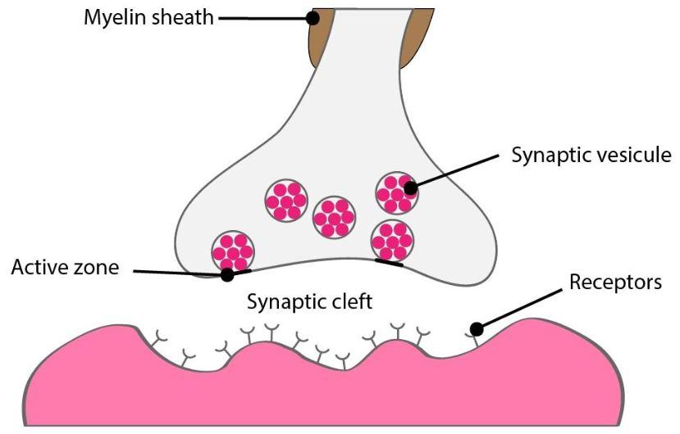
Neuroprotective
If an agent provides protection to any part of the body’s nervous system, it is said to provide neuroprotection.
Neuroscience
The scientific disciplines concerned with the development, structure, function, chemistry, pharmacology, clinical assessments and pathology of the nervous system.
Neurotransmitters
Chemical substances that carry impulses from one nerve cell to another; found in the space (synapse) that separates the transmitting neuron’s terminal (axon) from the receiving neuron’s terminal (dendrite).

O
Onset
The time of appearance of the first symptoms of a condition, prior to seeking diagnosis.
Orthotics
Orthotics are special shoe inserts, splints, or braces that are used to relieve various gait problems, foot problems, help increase balance, or take pressure off sore spots on the feet. Orthotics may be custom molded for your feet, or may be pre-formed supports, such as simple arch supports.
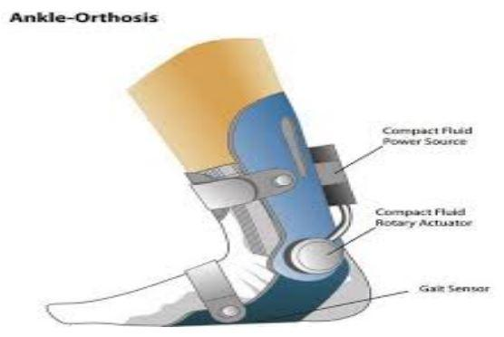
Oxidative Stress
Accumulation of destructive molecules called free radicals can lead to motor neuron death. Free radicals damage components of the cells’ membranes, proteins or genetic material by “oxidizing” them which is the same chemical reaction that causes iron to rust. Some patients with familial ALS have mutations in the gene for superoxide dismutase type 1 (SOD1). SOD1 normally breaks down free radicals, but mutant SOD1 is unable to perform this function.
P
Paraparesis
Muscle weakness.
Paraplegia
Loss or impairment of motor function of the legs and lower part of the body.
Paresthesia
An unusual sensation which may include numbness, tingling, burning, or prickling. It is sometimes described as “the sensation of pins and needles” or “as if my leg were asleep”.
Penetrance
The likelihood that a particular gene will result in the disease or disorder. For example, the BRCA1 breast cancer susceptibility gene, even though dominant, does not have complete penetrance. The risk of a person with this gene getting breast cancer by age 65 is 80 percent rather than 100 percent. In the case of dominant forms of HSP, though very high, is not always complete.
Pharmacology
The study of drugs and their origin, nature, properties and effects upon living organisms.
Phenotype
The expression of the genes present in an individual. This may be directly observable (eye color) or apparent only with specific tests (blood type). Some phenotypes such as the blood groups are completely determined by heredity, while others are readily altered by environmental agents.
Primary Lateral Sclerosis (PLS)
PLS is the term for a group of Upper Motor Neuron (UMN) disorders that cause progressive spasticity (stiffness) and weakness in the legs, arms, and speech and swallowing muscles. Also considered a benign variant of ALS.
Protein
Proteins are large molecules required for the structure, function, and regulation of the body’s cells, tissues, and organs. Each protein has unique functions. Proteins are essential components of muscles, skin, bones and the body as a whole.
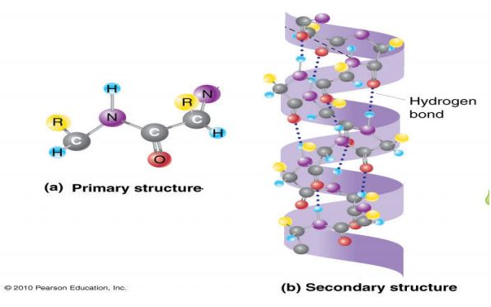
Q
There are no entries for this letter
R
Recessive
A recessive gene generally requires that both corresponding genes are affected in order for the disorder to appear. If the person has one affected gene and one unaffected gene, the disorder will not appear, but the person is considered a “carrier” of the gene. Therefore, usually only children who inherit an affected gene from both parents will show the effects of the disorder.
Rilutek
The only FDA approved drug available to treat ALS. It inhibits glutamate release and prolongs life approximately three months. Riluzole is the generic name of Rilutek.
RNA
A nucleic acid found in all living cells. The primary function of RNA is protein synthesis within a cell. However, RNA is involved in various ways in the processes of expression and repression of hereditary information. The three main functionally distinct varieties of RNA molecules are: (1) messenger RNA (mRNA) which is involved in the transmission of DNA information, (2) ribosomal RNA (rRNA) which makes up the physical machinery of the synthetic process, and (3) transfer RNA (tRNA) which also constitutes another functional part of the machinery of protein synthesis.
S
Sclerosis
A hardening within the nervous system, especially of the brain and spinal cord, resulting from degeneration of nervous elements such as the myelin sheath.
Sex Chromosomes
One of the pair of chromosomes linked to gender, known as the X chromosome and the Y chromosome. Females have two X chromosomes; males have an X and a Y chromosome.
Sialorrhea
Drooling resulting from the lack of spontaneous, automatic swallowing to clear excessive saliva in the mouth.
Spasticity (Spastic)
Increased muscle tone, resulting in “stiffness”. Often involves an exaggeration of the tendon reflexes.
Spasms
A spasm is a sudden uncontrollable contraction of a muscle. It can be a single muscle cramp along with a burst of pain or a series of spasms lasting several minutes.
Spinal Cord
Part of the central nervous system extending from the brain through the vertebrae of the spinal column. Thirty-one pairs of spinal nerves arise from the sides of the spinal cord. The spinal cord carries information from the body to the brain and signals messages from the brain to the body.
Spinal-bulbar Muscular Atrophy
An X-linked motor neuron recessive disorder characterized by slowly progressive skeletal muscle weakness, especially in the muscles of mouth and throat. Also called Kennedy’s Disease.
Spinal Muscular Atrophy
A group of predominantly autosomal recessive motor neuron disorders characterized by severe hypotonia and muscle weakness due to lower motor neuron dysfunction.
Sporadic Spastic Paraparesis
See (Apparently Sporadic) Spastic Paraplegia (SP)
Stem Cells
Undifferentiated cells that can differentiate into many different cell types when subjected to the right biochemical signals. The most versatile stem cells, called pluripotent stem cells, are present in the first days after an egg is fertilized by sperm. Researchers believe they can coax stem cells to become whatever tissues patients need. Stem cells come from embryos, bone marrow and umbilical cords.

Stem Cell Transplant
Transplantation of stem cells from various sources has provided improvement in animal spinal neurodegenerative disease models such as stroke, epilepsy, Parkinson’s and spinal cord injury. Human trials are promising, but not complete.
Stretch Receptors
Nerve endings in muscles and tendons that send messages to the spinal cord when the muscles are stretched.
Superoxide Dismutase (SOD)
An enzyme that destroys superoxide, a highly reactive form of oxygen. It protects against superoxide damage. Twenty percent (20%) of ALS patients have mutations in the gene for copper/zinc superoxide dismutase type SOD1. SOD1 normally breaks down free radicals but mutant SOD1 is unable to perform this function.
Synapses
Junctions at which neurons communicate with target cells, such as a muscle cell or axon of another neuron. A tiny gap between the ends of nerve fibers across which nerve impulses pass from one neuron to another; at the synapse, an impulse causes the release of a neurotransmitter, which diffuses across the gap and triggers an electrical impulse in the next neuron.
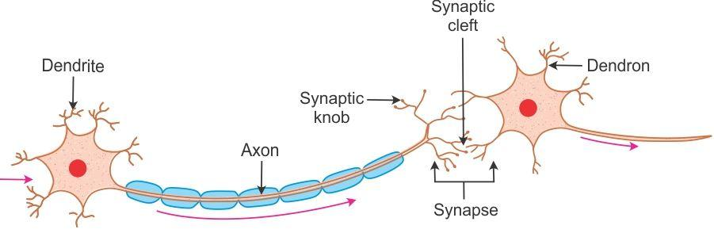

T
Therapeutic Index
A general way of measuring an effective dose of a drug and its toxicity.

Trait
A genetic trait is any sort of distinguishing quality that can be inherited, such as hair color or eye color. Traits are determined by information contained in genes. While many traits are harmless, others can be harmful, such as birth defects or other types of physical disorders.
Transgenic
An organism whose sperm or egg contain genetic material originally derived from an organism other than the parents or in addition to the parental genetic material.
U
Uncomplicated HSP
Most forms of HSP are referred to as “uncomplicated” HSP because symptoms are confined to the lower body.
Upper Motor Neurons
Nerve cells (neurons) originating in the brain’s motor cortex and running through the spinal cord.
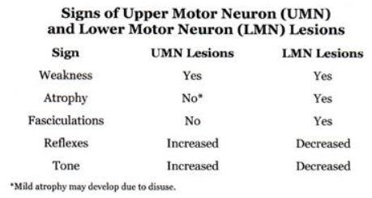
V
There are no entries for this letter
W
There are no entries for this letter
X
X Chromosome
One of the two sex chromosomes. All humans have one X chromosome. Females have two X chromosomes, while men have one X chromosome and one Y chromosome.
X-Linked
A gene that is located on the X chromosome. Females have two X chromosomes, while males have one X chromosome and one Y chromosome. If the trait is recessive, females with an affected gene on one X chromosome will not show symptoms unless the corresponding gene on the other X chromosome is also affected. Since men only have one X chromosome, if they have an affected gene, they will have the disorder, as there is no “normal” gene to compensate for it.
Y
Y Chromosome
One of the two sex chromosomes. Only males have a Y chromosome. Men have an X chromosome and a Y chromosome, while females have two X chromosomes.
Z
There are no entries for this letter

