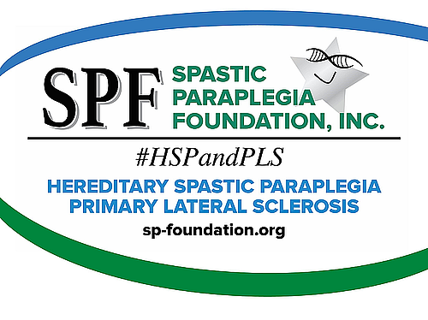

Welcome to The Spastic Paraplegia Foundation (SPF)
There is lots of great information about HSP & PLS on the SPF website: sp-foundation.org

In the HSP & PLS section, you will find information about each disease, the ‘Differences’, ‘Heredity & Genetics’, and ‘Treatments and Therapies’.

The Get Involved section is probably the most frequented part of the website. ‘Donate Here’ helps raise money for SPF. The primary goal of SPF is to raise money to find a cure and 97% of donations go toward funding research. There are many ways to donate directly or other ways like Planned Giving, creating a fundraiser to get family and friends involved and more.

There are in-person and virtual ways to participate under ‘Events’ which are in an ‘Events Calendar’. There are also yearly events: ‘Annual Conference’, ‘Awareness Week’, and more. There is also a ‘SPF Store’ where there are lots of different items you can purchase to show your support for HSP, PLS or SPF.

Under ‘Ambassadors’, you can volunteer to help others with HSP/ PLS. There is information on ‘Support Groups’ and ‘How to Help’. Plus, you can Volunteer on a Committee, find information on ‘SPF Kids & Youth’, or ‘SPF Talks’ which discusses a variety of topics of interest over Zoom.

The section called Resources contains a great deal of useful information. Here you can ‘Register/Update with SPF’. There are also informational booklets on HSP & PLS which can be printed and given to family members to help them better understand your situation and a glossary of medical terms. Under ‘Directories’, you can find an ambassador or see lists of Physician/Clinics and Physical Therapists in your area. You will also find our ‘Newsletters’ (Synapse and Spastic World, ‘Self-help Guides’, and ‘Government Aid & Charity Programs’.

Research contains current and past ‘Research Grants’ that the SPF has funded with donations, ‘Current Studies Seeking Participants’, ‘SP-COE’ (Spastic Paraplegia – Centers of Excellence) which is the most exciting and newest step forward for HSP/PLS, plus ‘Genetic Testing and International Organizations’, patient registry information, and a section for investigators to submit a research proposal.

In The Foundation section, you will learn about SPF and its history. You will also meet the ‘Board of Directors’, learn about the ‘Science Advisory Board’, and find ‘Corporate Documents’.

The last section is Media which has ‘Public Service Announcements’ about the latest updates and news.

If there is still something you would like to find just type it in the SEARCH area on the top of all pages or contact your SPF Ambassador.

Again, WELCOME to SPF. Please reach out to us anytime and join in our discussion and fundraising events.

