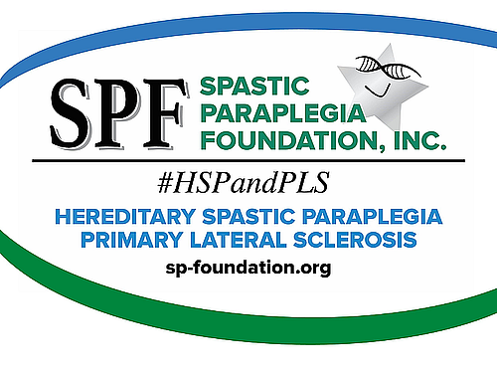

I'd like to welcome you to The Spastic Paraplegia Foundation.

This website has lots of helpful information on HSP and PLS finding a doctor, support groups, learning more about motor neuron diseases, etc. It can be overwhelming but know you are not alone in the fight!

First, please join The Spastic Paraplegia Foundation at https://sp-foundation.org/news-resources/stay-informed.html.

If there is ANYTHING you think of that I can help with, give me a call or send me an email. If I don't know the answer, I'll find out who does!

Thank you for joining SPF,
[Your Name]
SPF Ambassador

P.S. I live [put in proximity to them].

Also, please let me know when you receive this, so I’ll know that I got your address correct. [Always include this last part!]

