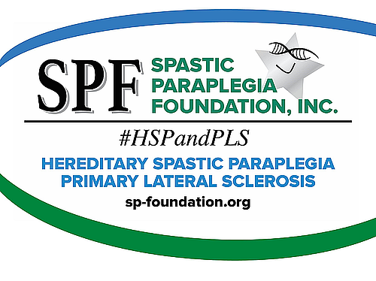

Welcome to The Spastic Paraplegia Foundation (SPF)
There is lots of great information about HSP & PLS on the SPF website: sp-foundation.org

In the HSP & PLS section, you will find information about each disease, the ‘Differences’, ‘Heredity & Genetics’, and ‘Treatments and Therapies’.

The Get Involved section is probably the most frequented part of the website. ‘Donate Here’ helps raise money for SPF. The primary goal of SPF is to raise money to find a cure and 93% of donations go toward funding research. There are many ways to donate: create a fundraiser, use Amazon Smile to shop online, schedule a monthly monetary gift and more.

There are in-person and virtual ways to participate under ‘Events’ which are in an Events Calendar. There are also yearly events: Annual Conference, Awareness Week, and more. In the ‘SPF Store’ there are lots of different items to choose from along with a variety of logo designs. Under ‘Be an Ambassador’, you can volunteer to help others with HSP or PLS. Plus, there is information on ‘Support Groups’ and ‘How to Help’.

The section called Resources contains a great deal of useful information. Here you can ‘Register/Update with SPF for FREE’. There are informational booklets on HSP & PLS which can be printed and given to family members to help them better understand your situation and a glossary of medical terms. Under ‘Directories’, you can contact an Ambassador or see lists of Physician/Clinics and Physical Therapists. You will also find information on our ‘Newsletters’ (Synapse and Spastic World), ‘HSP Forum’, ‘Self-help Guides’, ‘Government Aid & Charity Programs’, and ‘Special Offers’.

Research contains a description of SPF’s mission, ‘Research Impact’, ‘Current Studies Seeking Participants’, ‘Genetic Testing and International Organizations’, patient registry information, and submitting a research proposal.

In The Foundation section, you will learn about SPF and its history. You will also meet the ‘Board of Directors’, learn about the ‘Science Advisory Board’, and find ‘Corporate Documents’.

If there is still something you would like to find just type it in the SEARCH area on the top of all pages or contact a SPF Ambassador.

You are no longer alone in this fight!

