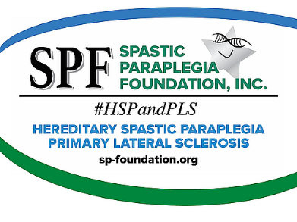

Your Name
Your Street Address
Your City, State, Zip Code
Your Email Address
Your Phone Number

Date

Name of Person
Business Name
Street address
City, State, Zip Code

Dear ______,

Please consider supporting the Spastic Paraplegia Foundation (SPF). SPF is the only organization in the North Americas which supports research and awareness of the rare upper motor neuron diseases of Hereditary Spastic Paraplegia (HSP) and Primary Lateral Sclerosis (PLS). The recorded number of cases of HSP and PLS are low because of the lack of awareness of these diseases, approximately 30,000 people in the United States have been diagnosed with HSP and 2,000 with PLS. It is difficult to secure grants for studying rare diseases like HSP and PLS because of the lack of data, and SPF volunteers work daily to help fill these gaps.

The Spastic Paraplegia Foundation (SPF) has an Annual Conference for anyone affected by HSP and PLS. The conference has medical professionals presenting the latest research and allows the attendees to meet others in person who share the same disease. Your sponsorship will help SPF subsidize the cost of the conference; any excess will be used toward medical research for a cure. I realize that not all the marketing sponsorship opportunities are of interest to you; however, please let us know which of the listed items might work for you. We would like to recognize your names at least.

Enclosed are the following documents from Norma Pruitt, SPF Executive Director: a cover letter, Conference Sponsorship Opportunities, IRS Tax-Exempt status letter, and a summary of HSP and PLS symptoms from the website, SP-FOUNDATION.ORG.

Check donations can be made to the Spastic Paraplegia Foundation and the mailing address is: 1605 Goularte Place, Fremont, CA 94539-7421. Credit card donations may be made online at SP-FOUNDATION.ORG.

The SPF is an all-volunteer 501 (c) 3 organization which just concluded a record fundraising effort in 2021, raising $1,300,000, enough for eight grants for medical researchers. We are building momentum! Please contact me with any questions or feel free to reach out to Norma Pruitt at 270.705.0506 or SPFKentucky@gmail.com.

Gratefully yours,

Your Name (and Signature above)

