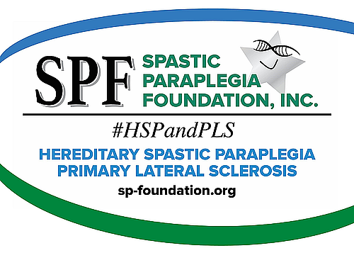

I'd like to welcome you to The Spastic Paraplegia Foundation.

This website has lots of helpful information on HSP and PLS finding a doctor, support groups, learning more about motor neuron diseases, etc. It can be overwhelming but know you are not alone in the fight!

If there is ANYTHING you think of that I can help with, give me a call or send me an email. If I don't know the answer, I'll find out who does!

Thank you for joining SPF,
[Your Name]
SPF Ambassador

P.S. I live [put in proximity to them].

Also, please let me know when you receive this, so I’ll know that I got your address correct. [Always include this last part!]

