A patient’s guide through the maze of Hereditary Spastic Paraplegia
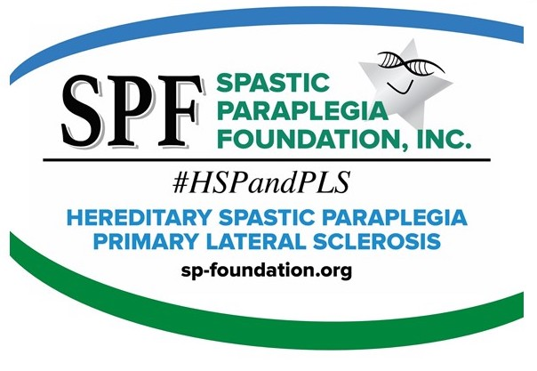

WHAT IS HSP?
HEREDITARY SPASTIC PARAPLEGIA (HSP) IS A GROUP OF RARE, INHERITED, NEUROLOGICAL DISORDERS. THEIR PRIMARY SYMPTOMS ARE PROGRESSIVE SPASTICITY AND WEAKNESS OF THE LEG AND HIP MUSCLES.
Researchers estimate that over 90 different types of HSP exist. The estimated number of HSP cases in the United States is 20,000 – 30,000.

WHAT ARE THE SYMPTOMS OF HSP?
The hallmark of HSP is progressive difficulty walking due to increasingly weak and stiff (spastic) muscles. Symptoms appear in most people between the second and fourth decade of life, but they can start at any age.
Initial symptoms are typically difficulty with balance, stubbing the toe or stumbling. Changes begin so gradually that other people often notice the change first. As the disease progresses, canes, walkers and eventually wheelchairs may become needed, although some people never require assistive devices.
WHAT SHOULD I EXPECT?
Everyone is different! Just like a snowflake, we are all individuals, but together we are snow.
These seem to be the most common symptoms. You might experience some or all of these:
• Muscle tightness in legs/feet
• Imbalance: Frequent Falls
• Muscle spasms or cramps
• Sensitivity to cold
• Excessive muscle tone
• High arched feet
• Fatigue
• Frequency/urgency of urination

DOES STRESS AFFECT MY SYMPTOMS?
Many people find the tightness in their muscles worsens when they are angry, stressed, or upset. This may make it more difficult to walk and speak. It is unknown exactly how emotions affect muscle tone, but it may involve adrenalin levels. Most people also report increased stiffness in cold weather.

BASIC CELL BIOLOGY EXPLAINED
I am sure you have gone to the doctor’s office and left there just as confused as you went in, maybe more!
HSP is caused by degeneration of the upper motor neurons in the brain and spinal cord. Even though the trouble may be with your legs, upper motor neurons control voluntary movement.
The cell bodies of these neurons are located in the motor cortex area of the brain. They have long, hair-like processes called axons that travel to the brainstem and down the spinal cord.
Axons relay the messages to move to lower motor neurons that are located all along the brainstem and spinal cord. Lower motor neurons then carry the messages out to the muscles.
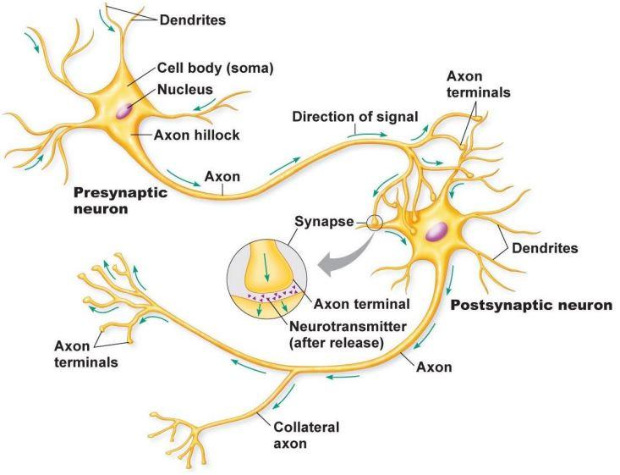
When upper motor neurons degenerate, the correct messages cannot reach the lower motor neurons, and the lower motor neurons cannot transmit the correct messages to the muscles. As the degeneration continues, spasticity and weakness increase. The legs are affected because degeneration occurs primarily at the ends of the longest nerves in the spinal cord, which control the legs. In some cases, the upper body can be minimally affected as well, leading to problems with the arms or speech and swallowing muscles.
The legs are affected because degeneration occurs primarily at the ends of the longest nerves in the spinal cord which control the legs.
WHAT CAN I DO NOW?
“There’s no cure or magic pill, there are only treatments.” – Dr. John K. Fink
Treatment is focused on symptom relief, such as medication to reduce spasticity; physical therapy and exercise to help maintain flexibility, strength, and range of motion; assistive devices and communications aids; supportive therapy and other modalities.
This material has been reviewed by Dr. John Fink, M.D., SPF Medical Advisor. Please see Glossary to help with medical terms.
Please note: The information in this section is not intended to be taken as replacement for medical advice. Individuals should consult with a qualified health-care practitioner. HSP affects individual people in different ways, and as a result, treatment programs will vary. Although there is no way to stop, slow or reverse the progressive disability of these disorders, there are therapies that can help enhance function and comfort and promote general physical and emotional well-being. You are an important member of the team, too.

STRETCHING
There are several benefits to stretching as soon as you have been diagnosed. “I stretch several times each day!” says Jackie Wellman, SPF Board Member and Iowa State Ambassador. The overall benefit you will find is the alleviating of the leg cramps or spasms that become more intense with stress and exertion.
If you want to find a good stretch for you, ask your physician or therapist. Basically, you want to especially stretch your hamstrings, calves, hips and Achilles tendons (ankle).
EXERCISE – “USE IT OR LOSE IT”
Exercising can improve the following:
- Muscle tone and strength without bulk
- Joint mobility
- Balance
- Flexibility
- Breathing
- Posture
- Sleep
- Mental and physical stamina
- Restorative
- Rehabilitative
- Meditative
- Elongate the spine
- Lengthen muscles
- Learn how to carry your body in the proper way
- After exercising you will feel more relaxed, aligned, rejuvenated and centered
Exercising can become a complete lifestyle.

PHYSICAL THERAPY
Physical Therapy seeks to restore or maintain the ability to move. Therapies generally focus on reducing muscle tone, maintaining or improving range of motion and mobility, increasing strength and coordination, and improving comfort.
Physical Therapists will assess joint motion, muscle strength and endurance, posture, pain, heart and lung function and performance of daily living activities to develop an individualized program.

DRUG THERAPY
Baclofen
The most commonly used medication to help relax muscles or reduce tone. Brand name: Lioresal. Outside the United States: Alpha-Baclofen, Baclon, Baclosal, Baclospas, Baklofen, Clofen, Lebic, Mulax, Pacifen, Spinax.

To be effective, the dose must be large enough to cross the blood/brain barrier and reach the spinal cord (The blood/brain barrier is the body’s way of keeping chemicals from getting to the brain and spinal cord).
If the high dosage results in too much sedation, the intrathecal Baclofen pump can be considered. The Baclofen pump is surgically implanted in the abdomen and delivers small, continuous doses of medication directly to the spinal canal. This can result in better performance with minimal side effects. Surgery is required to implant the pump under the skin of the abdomen and a catheter connects it to the spine. The pump can be programmed to release a specific amount of medicine at select times, which can be adjusted without surgery. The pump needs to be refilled every one (1) to three (3) months.

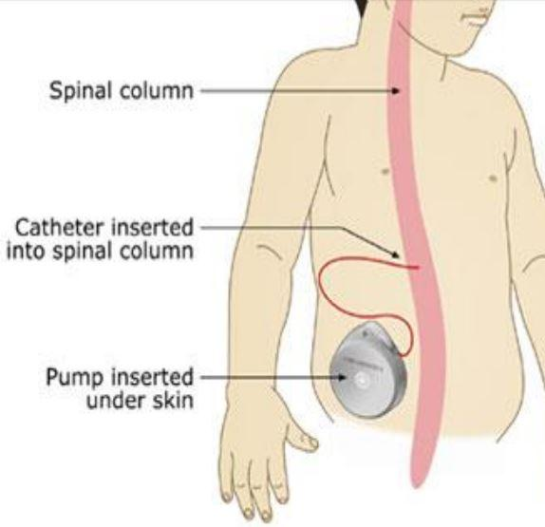
Tizanidine
A short acting drug useful for treating nocturnal spasms and for intermittent management of spasticity. Brand name: Zanaflex. Outside the United States: Sirdalud, Sirdalud MR, Sirdalud Retard, Ternelax, Ternelin
Diazepam and Clonazepam
Sedatives that slow the central nervous system, side effects are common. Brand name: Klonopin
Dantrolene Sodium
Works to reduce muscle contraction, may cause liver damage. Brand names: Dantrium, Dantrium
Other treatments used for spasticity:
BTX Botulinum Toxin
Chemodenervation by injections of botulinum toxin type A (-A) directly into the muscle, lasts about six months. Brand name: Botox (chemodenervation)
Gabapentin
Widely used to treat seizures and neuropathic pain, may be useful in reducing spasticity. Brand name: Neurontin

SUPPLEMENTS
A list of popular supplements often used by individuals with HSP are below. Their inclusion is for informational purposes only and not a recommendation or endorsement. For information on vitamins and food supplements, visit the USDA Food and Nutrition Information Center. And of course, consult your doctor or pharmacist
Alpha-Lipoic Acid
Alpha-lipoic acid (ALA) is a non-prescriptive dietary supplement. It is a powerful antioxidant and is used to treat individuals with liver disease and Amanita mushroom poisoning.
Ashwagandha
Improves physical energy and athletic ability, increases immunity to colds and infections and increase sexual capacity and fertility.
Vitamin B-12
Vitamin B-12 may benefit your body by boosting your energy, improving your memory and helping prevent heart disease.
Vitamin B-Complex
Vitamin B-Complex is composed of eight B vitamins and helps support or promote cell health, growth of red blood cells, energy levels, good eyesight, healthy brain function, good digestion, healthy appetite, proper nerve function, hormones and cholesterol production, cardiovascular health, and muscle tone.
Bacopa
Supports healthy cognitive function, attention, learning, focus, and memory. Promotes calmness, relaxation, and focus. Supports positive mood and emotional well-being. Protects the brain from oxidative damage.
Co-Enzyme Q10
Co-Enzyme Q10 is a non-prescription dietary supplement that is involved in a variety of cellular processes. It has been noted to have antioxidant properties, such as free-radical scavenging. CoQ10 is indicated for heart failure and mitochondrial cytopathies.
Researchers in a Massachusetts General Hospital study found that CoQ10 extended the survival in a mouse model of ALS. They also demonstrated positive findings in Parkinson’s and Huntington’s Disease. It is thought that CoQ10 may be useful for the treatment of neurodegenerative diseases.
There have not been studies to suggest a recommended dosage for people with neurodegenerative diseases. Patients, while under the care of their physician, appear to be taking 100mg three times per day. CoQ10 is fat-soluble and should be taken with a fatty meal. It is available over the counter at any store selling dietary supplements functioning of nerves and muscles.
Vitamin D
Vitamin D has multiple roles in the body, promoting healthy bones and teeth, supporting immune, brain, lung function, cardiovascular health and nervous system health. Also, research has found a link between Vitamin D and muscle function and explains why lower levels can lead to physical fatigue.
Vitamin E
Vitamin E is a fat-soluble vitamin found in many foods. It is a powerful vitamin and antioxidant that detoxifies free radicals. It helps protect the cells of the body from damaging chemical reactions and it is important for the proper functioning of nerves and muscles.
Green Tea
An antioxidant, helps blood flow to the brain, lower cholesterol prevents a range of heart-related issues and help block the formation of plaques that are linked to Alzheimer’s disease
Fish Oil and Quinine
Individuals have reported benefit from fish oil, which blocks activity of the sodium channels used to contract muscles and quinine. Quinine is found in tonic water.
Magnesium
Good for powering the heart and aiding in constipation, but also great for alleviating muscle cramps.
Melatonin
A supplement which promotes relaxation. Some people find it helpful in promoting restful sleep.
Oregano Oil
Has been shown to function as potent antioxidants that can prevent oxygen-based damage to cell structures throughout the body.
Orthotics (AFOs = Ankle – Foot – Orthotics)
Orthotics are special shoe inserts, splints or braces used to help relieve gait problems and foot problems. They can also help increase balance or remove pressure from sore spots.
Protandim
Protandim is an herbal dietary supplement made up of 5 herbal ingredients including Turmeric, Green Tea, Milk Thistle, Bacopa, and Ashwagandha. It reduces the bodies oxidative stress, supports the healthy aging process, promotes the cell’s natural ability to repair and rejuvenate itself, and protect cells from free radical damage.
Nutrition
There are no known studies indicating that vitamins or food supplements are an effective treatment for PLS or HSP. However, there are studies indicating particular antioxidants may be of benefit in related neurologic conditions, such as ALS. It is generally recognized that eating a healthy, well-balanced diet is important to overall health. Individuals should always get recommendations from their physicians before taking any vitamins or food supplements. A great additional source of information is the USDA Food and Nutrition Information Center.
See also: Gluten Free, Vegetarian, Vegan, Paleo
ALTERNATIVE MEDICINE
Alternative medicine is usually described as practices not generally accepted as part of the standard approaches used by licensed physicians or other licensed health care providers. Practitioners using these methods are generally not licensed as health care clinicians, but may be licensed for a specific method, such as acupuncture or massage, or licensed in another health field, such as nursing.
Some licensed physicians and other health care providers may use an alternative medicine method or refer patients to practitioners of an alternative medicine method. Many individuals pursue treatments on their own.

A list of popular alternative medicine modalities often used by individuals with HSP are below. Their inclusion is for informational purposes only and not a recommendation or endorsement.

Acupuncture
An ancient system of Chinese medicine where thin needles are inserted into specific points on the body. Chinese medicine identifies these points as conducive to energy and connected to specific organ systems in the body. The purpose is to alleviate various health conditions. Some individuals have indicated an improvement with spasticity after treatment.
Alexander Technique
The theory behind the Alexander Technique is that by reeducating a person’s mind and body, tension can be reduced and ease of movement increased. Most information appears to be from commercial websites.
Biofeedback
Biofeedback treatment uses relaxation and visualization (imagery) to lower stress levels, alleviate headaches, or reduce blood pressure. Instruments measure information about bodily processes, such as muscle tension, skin temperature, brain waves, and respiration. Several studies have shown visualization to be very useful in stress reduction. See Yahoo Guided Imagery.
Chiropractic treatment
A treatment method that depends primarily on manipulating or adjusting the spine to prevent disease and treat pain and other ailments. Some people have found that chiropractic spinal manipulation can help reduce their back pain, and some claim a temporary improvement in their gait.
Massage Therapy
The use of touch and various manipulation techniques. To move muscles and soft body tissues to relieve stress, tension, and pain. For more information, see the National Certification Board for Therapeutic Massage and Bodywork.
Meditation
Meditation can wipe away the day’s stress, bringing with it inner peace. If stress has you anxious, tense and worried, consider meditation. Spending even a few minutes in meditation can restore your calm and inner peace. Meditation is not a replacement for traditional medical treatment. But it may be a useful addition to your other treatments. Some research suggests that meditation may help people manage symptoms of conditions such as:
Anxiety disorders
Asthma Cancer
Depression
Heart disease
High blood pressure
Pain
Sleep problems
Transcutaneous Electrical Nerve Stimulation (TENS)
TENS units work by delivering small electrical impulses through electrodes that have adhesive pads to attach them to a person’s skin. These electrical impulses flood the nervous system, reducing its ability to transmit pain signals to the spinal cord and brain.
Upper Cervical Care
Upper cervical care is a natural form of health care that focuses on locating and removing misalignments from one of the top two vertebrae in the spinal column.
WHERE DO I GO FOR HELP?
SPF (Spastic Paraplegia Foundation)
www.sp-foundation.org
NORD (National Organization for Rare Disorders) www.rarediseases.org
NEALS (Northeast Amyotrophic Lateral Sclerosis) www.alsconsortium.org
NIH (National Institute of Health) www.nih.gov
Social Media – SPF Face Book page, Etc.

WHERE CAN I GO FOR RESEARCH?
Individuals are encouraged to participate in clinical trials that will further the understanding of our conditions and their diagnosis, treatment, and cures. Please go to clinical trials and search on key words “Primary Lateral Sclerosis” or “Hereditary Spastic Paraplegia” to find out about relevant clinical trials.
www.clinicaltrial.gov

WHERE CAN I FIND A DOCTOR?
Not all doctors are aware or can spot and treat HSP. Go to sp-foundation.org and click on “Find a Physician” for a list of doctors in your area.
*Helpful Tip – carry a card in your wallet with all of your drugs and supplements listed. Include any allergies.

WHAT ABOUT INSURANCE?
Insurance companies are hard to understand normally. Add to it our complicated coverage! Basically, we are going to say, “Try, try, try!” You are your own advocate here. Do not let, “No” be the final word. You never know what can happen. You have nothing to lose—right? One thing that we have learned in dealing with Insurance companies, ALWAYS document WHO you talked to, WHAT TIME AND NUMBER you called, and WHAT WAS THE OUTCOME OR RESULT?

